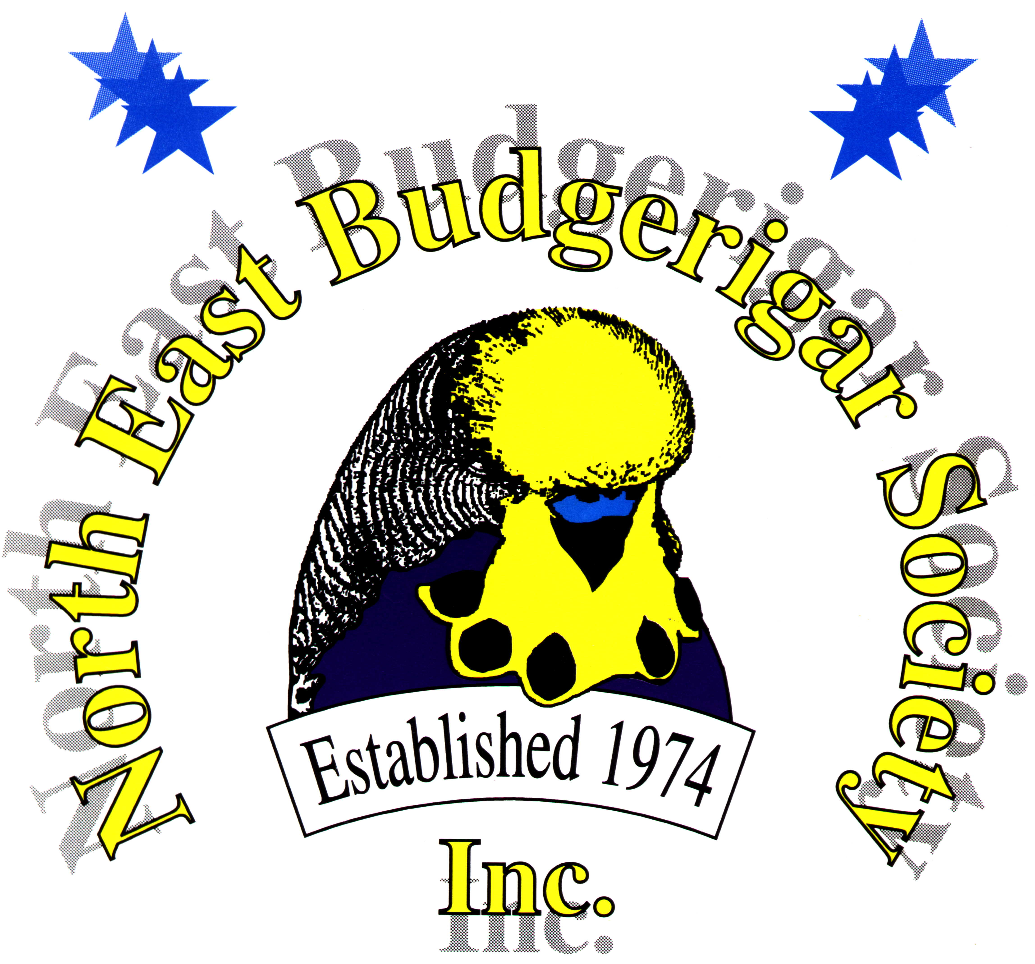

Lloyd Edwards Breeder Show

Class Schedule 2023

1 NORMAL GREEN COCK 27 GREYWING ASC COCK 2 NORMAL GREEN HEN 28 GREYWING ASC HEN 3 NORMAL GREY GREEN COCK 29 CINNAMONWING ASC COCK
4 NORMAL GREY GREEN HEN 30 CINNAMONWING ASC HEN
5 NORMAL BLUE COCK 31 SPANGLE DOUBLE FACTOR COCK
6 NORMAL BLUE HEN 32 SPANGLE DOUBLE FACTOR HEN
7 NORMAL VISUAL VIOLET COCK 33 OPALINE ASC COCK
8 NORMAL VISUAL VIOLET HEN 34 OPALINE ASC HEN
9 NORMAL GREY COCK 35 OPALINE AOSV COCK
10 NORMAL GREY HEN 36 OPALINE AOSV HEN
11 NORMAL YELLOW FACED 37 CLEARBODY ASC COCK
BLUE ASC COCK 38 CLEARBODY ASC HEN
12 NORMAL YELLOW FACED 39 LACEWING COCK BLUE ASC HEN 40 LACEWING HEN
13 NORMAL GOLDEN FACED 41 FALLOW ASC /ASV COCK
BLUE ASC COCK 42 FALLOW ASC /ASV HEN
14 NORMAL GOLDEN FACED 43 NORMAL SPANGLE ASC COCK
BLUE ASC HEN 44 NORMAL SPANGLE ASC HEN
15 BLACKEYED SELF COCK 45 SPANGLE AOSV COCK
16 BLACKEYED SELF HEN 46 SPANGLE AOSV HEN
17 DILUTE YELLOW/WHITE COCK 47 DOMINANT PIED ASC /ASV COCK
18 DILUTE YELLOW/WHITE HEN 48 DOMINANT PIED ASC /ASV HEN
19 LUTINO COCK 49 RECESSIVE PIED ASC/ ASV COCK
20 LUTINO HEN 50 RECESSIVE PIED ASC /ASV HEN
21 ALBINO COCK 51 AUST WHITE CAP COCK
22 ALBINO HEN 52 AUST WHITE CAP HEN
23 DARK EYED CLEAR COCK 53 CRESTED ASC /ASV COCK
24 DARK EYED CLEAR HEN 54 CRESTED ASC /ASV HEN
25 CLEARWING ASC COCK 55 AOSV OR NSV COCK
26 CLEARWING ASC HEN 56 AOSV OR NSV HEN

ASC: ANY STANDARD COLOUR; ASV: ANY STANDARD VARIETY
AOSV: ANY OTHER STANDARD VARIETY; NSV: NON STANDARD VARIETY

ENTRIES AS PER THE ANBC STANDARD & MATRIX, UNLESS OTHERWISE INDICATED

