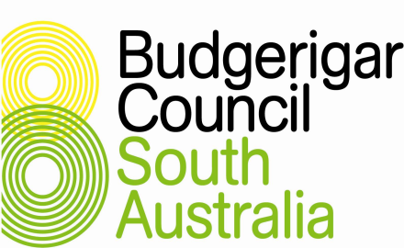

**LOGAN SHIELD STATE SHOW**

**SUNDAY – 28th MAY 2023**

**Enfield Community Centre, 540 Regency Road, Enfield**

Interclub Competition points are awarded for positions 1-12 in each class. Exhibitors must nominate the Society to which their points are to be allocated.

**Birds to be spotted but a minimum of shadow spots is acceptable for transport to the national show.**

**Photographs of birds selected in the team are not to appear in social media or the internet prior to judging at the national show.**

**2022 (Brown) ANBC ISSUED RINGS ONLY**

**All birds must be available for selection in the state team**

THE SHOW WILL BE HELD UNDER THE BCSA SHOW RULES

at the Enfield Community Centre, 540 Regency Road, Enfield.

Any Covid issues will be those stipulated by the Port Adelaide Enfield Council at the time.

Staging set up 7.00 am – 7.30 am by the exhibitors.

Birds to be benched between 7.30 am – 8.45 am.

Judging to commence at 9.30 am.

**Exhibitors not involved in benching or stewarding must remain clear of all staging until after all judging has been completed.**

Open to Public from 12.00 pm – 2.00 pm, approximately

**Entries (Postal, Phone or Email) to Wayne Weidenhofer, 86 Mentone Road, VICTOR HARBOR SA 5211. Phone:- 0435 032 125/85 524283**

**Email:-** [**wayneweedo@tpg.com.au**](mailto:wayneweedo@tpg.com.au) **or**

**bcsashowentries@gmail.com**

**Entries close 5.00 pm Saturday 20th May 2023**

Intermediate and Novice breeders please enter status on the entry form.

**NO LATE ENTRIES**

Ring Numbers are required and used by the Ring Coordinator to collate the 1st, 2nd, 3rd birds travelling to the National event.

**Entries $1 each capped at $20 plus postage and handling of $2.00 for return of cage stickers.**

**Total amount is payable when entries are presented for benching**

The Safety Officer has the right to reject any entries prior to judging for signs of illness or poorly prepared cages which are deemed hazardous to the birds.

All birds to be shown in the standard ANBC show cage **with powder coated cage fronts.** Stickers to be placed on the bottom left hand side of the cage. Equal parts of canary, jap millet and white millet are the only seeds permitted. Each cage to be fitted with an approved plastic drinker 4 spaces in from the left side of the cage, level with perches of 12 or 16 mm.

BIRDS MUST NOT BE REMOVED UNTIL DIRECTED BY THE SHOW MANAGER

**EXHIBITORS TO ASSIST WITH DE-STAGING AND CLEANUP PLEASE, BEFORE LEAVING THE VENUE. HOT WEATHER POLICY WILL APPLY**

**LOGAN SHIELD STATE SHOW CLASSES**

**Diploma & Rosette for 1st Bird in each class,**

**Rosette for 2nd & 3rd**

**10 kg of Maxiseeds for 1st Bird in each class.**

**Trophies for Best Bird in Show, Best Open, Intermediate and Novice**

1 Normal Green

2 Normal Grey Green

3 Normal Blue

4 Normal Violet

5 Normal Grey

6 Normal Yellow Faced Blue

7 Normal Aust Golden Faced Blue

# 8 Black Eyed Self

# 9 Dilute

10 Lutino

11 Albino

12 Dark Eyed Clear

13 Clearwing

14 Greywing

15 Cinnamonwing

16 Spangle Double Factor

17 Opaline

18 Opaline AOSV

19 Clearbody

20 Lacewing

21 Fallow

22 Spangle

23 Spangle AOSV

24 Dominant Pied

25 Recessive Pied

26 Australian White Cap

27 Crested ASC / ASV

28 Hens

ENTRIES AS PER THE ANBC STANDARD & MATRIX

**BCSA Organising Group 2023**

Wayne Weidenhofer Show Manager/Secretary

Wayne Bandt Electronics supervisor, SA Team details for the ANBC electronics team

Dennis Lomman Hall bookings, hall key, raffle prizes

Wayne Weidenhofer Show schedule.

Sue Adams Publicity/Media (No photos of birds on Social media)

Doug Lange Safety Officer/Bio Security (if needed)

Janet Harris Covid Marshalls (if needed), Rosettes

Ruth Lange Collection of entry fees when birds presented for benching.

Ruth Lange Sale of raffle tickets, Rosettes

Dennis Lomman Ring Supervisor (Michael Smith, Michael Crossley)

Staging Graeme Alchin

Bird Carers Michael Smith (Captain), Doug Lange, Troy Holmes and Ian Marshall

BCSA Team Carer John Mulley (Birds travelling by road to Ballarat)

**Judges Invitations will be sent out**

**Stewards Nominations to the Show Manager**

**Club liaison officers**

BSSA Sue Adams adamsfamily100@bigpond.com

NEBS John Mulley jmulley@bigpond.net.au

Port Pirie Peter Glassenbury [pglassen@bigpond.com](mailto:pglassen@bigpond.com)

Club liaison officers are the contact point for the Show Manager for clubs to nominate stewards, ensure distribution of the show schedule to their club members, and in the case of metropolitan clubs to ensure assistance for setup and cleanup.

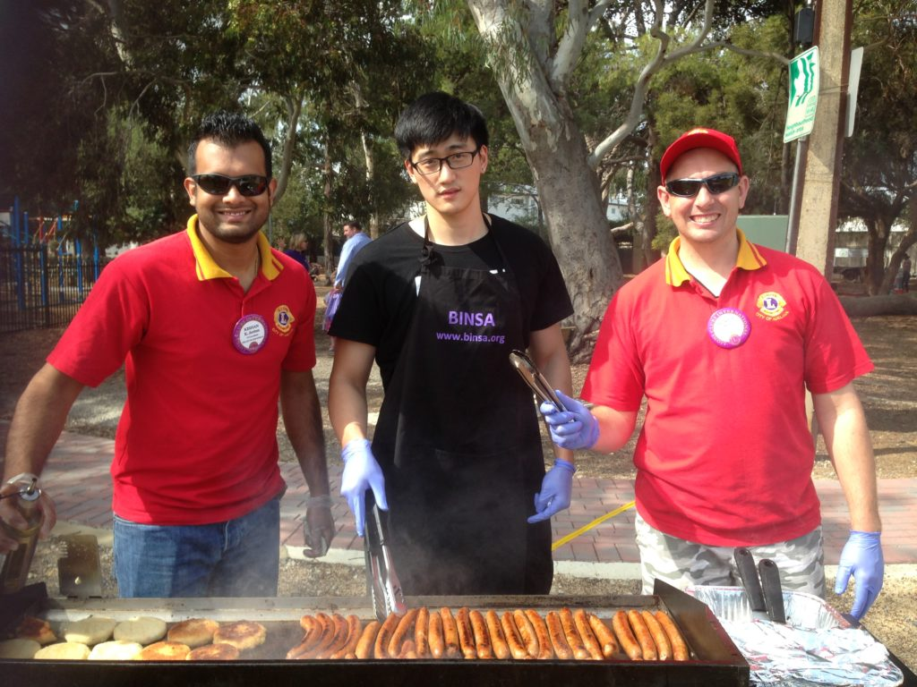

Catering is still being finalised or will be BYO like last year.

**MAJOR SPONSOR – MAXISEEDS. SUPPLYING THE WINNERS WITH THE BEST SEEDS UNDER THE SUN.**

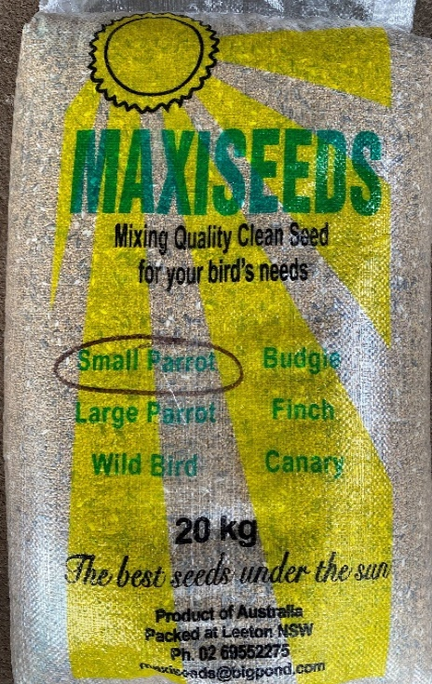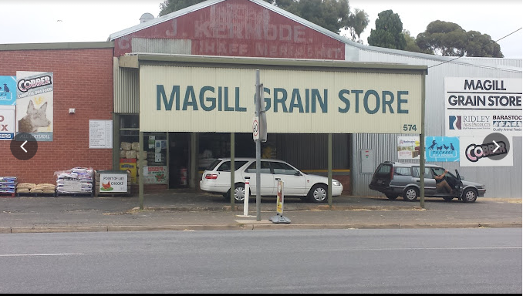

**THE LOGAN SHIELD**

The Logan Shield came into being after the Budgerigar Society of South Australia (BSSA), sent a team of birds to Melbourne to compete in their Gardner Shield. At the first attempt in 1974 with 11 Victorian teams competing, the BSSA came 4th and in 1975 came 3rd, this time against 15 Victorian teams. These results established the competitiveness of the South Australian birds.

It was suggested in 1977 that a similar competition be held to stimulate team spirit and friendly rivalry amongst budgerigar breeders from the 6 existing clubs in South Australia, including mixed bird clubs.

The then secretary of the BSSA, Lal Logan, who had held this position for 18 years, was honored to have his name used for the competition. Lal purchased and donated the shield which was then named in his honor and is still used to this day. The first Logan Shield was hosted by the BSSA on the 2nd of April 1977 at St John’s Hall, Halifax Street, Adelaide with the 6 existing clubs competing. The BSSA won with 196 points followed by Central Districts with 170, North East with140, Port Pirie with 131, Southern with 74 and Western with 60 points.

Unfortunately, at the time Lal was in hospital so he was unable to present his shield. In July of the same year he passed away and sadly never saw the shield competition take place.

The Logan Shield is a yearly reminder of Lal and his wife Thelma, both having so graciously donated their time and effort to the BSSA and to the budgerigar fancy since its foundation in South Australia in 1948.

In 1964, a meeting between a group of New South Wales, Victorian and South Australian budgerigar fanciers resolved that a National Teams Competition should occur. More serious discussions occurred in 1972 between these three states thus the first competition would commence in Victoria in 1975. The National Show has continued annually ever since and expanded to include seven states / zones which effectively brings together the best breeders and the best young exhibition budgerigars in Australia.

The Logan Shield is now our State’s selection show for the Australian National Budgerigar Council (ANBC) Championship Show and is hosted annually by the Budgerigar Council of South Australia (BCSA).

The Logan Shield remains as a reminder of a great budgie man.