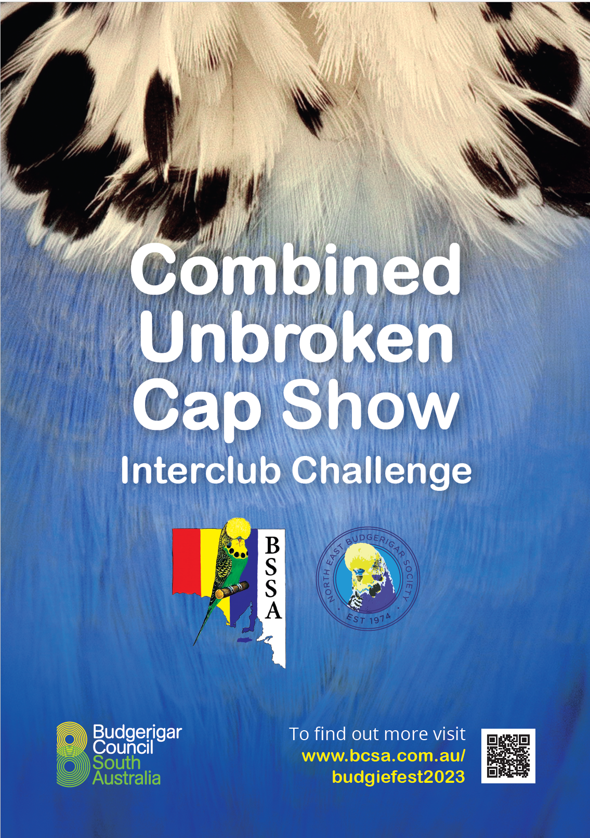

**NORTH EAST BUDGERIGAR SOCIETY Inc. and**

**BUDGERIGAR SOCIETY of SOUTH AUSTRALIA Inc.**

**COMBINED UNBROKEN CAP SHOW / INTERCLUB CHALLENGE**

The event is scheduled to take place on Saturday, October 28th, 2023, at the Campbelltown Council Function Centre located at 172 Montacute Road, Rostrevor, SA 5073. This event will also encompass the Budgie Fest 2023. The show will be conducted in accordance with the regulations and guidelines set out by NEBS.

For the UBC Shield, only cages that have powder coated fronts are permitted. For the pet section, any bird cage is acceptable. Note that this is a BCSA status movement show. Disqualification clauses as per adult birds apply plus one or more visible pin feather or visible adult coloured feather in the cap and/or a solid iris ring for unbroken caps. Judge’s decision is final. Unbroken cap and young birds must be rung with BLUE 2023 rings. Birds entered in the pet bird class do not need to be rung.

The entry fee for participation in the NEBS/BSSA Unbroken Cap challenge is set at $1.00 per bird, with a maximum cap of $20.00 for the UBC Shield. Entry to the pet bird class is FREE. It is important to note that juniors are exempt from paying the entry fee for either the UBC shield, or pet show. Additionally, it is crucial to adhere to the deadline for submitting entries, as late entries will not be accepted. This is due to the automated program's method of assigning numbers to cage stickers. Furthermore, it is advised to take into consideration that mail delivery times have been extended to up to six working days.

Participants have the option to submit their entries either by postal mail or email. The entry fee is required to be paid at the presentation of the birds at the show. Please make payment in the form of either cash or a cheque made out to the North East Budgerigar Society. Correspondence addressed to The Show Manager may be submitted either by postal mail to the following address: 6 East Terrace Kensington Gardens, SA 5068, or via email at [president@bcsa.com.au](mailto:president@bcsa.com.au). The entries are required to be submitted using the provided entry form, and the deadline for submission is 7.00pm on Friday, October 20th. Birds are to be benched between 7:30 am – 8:30 am, with commencement of the judging starting at 9:00 am sharp. The exception is birds entered into the pet bird category, which are benched from 11:00 am to 11:30 am.

If cage stickers are not received by the final postal delivery on Friday, October 27th, it is kindly requested to establish communication with the Show Manager, Troy Holmes, on 0419526753 no later than Friday evening. This will allow for the printing of duplicate stickers on the preceding night, ensuring their availability for distribution on the morning of the Show.

All birds to be shown in clean standard show cages approved by the North East Budgerigar Society with a recognized budgerigar breeders’ mix. The amount of seed on the cage floor is to be limited to approximately one kitchen measuring cup. Each cage to be fitted with an approved plastic drinker 4 spaces in from the left side of the cage, level with the perch. Stickers to be placed on the bottom left-hand side of the cage.

The Safety Officer has the right to reject entries prior to judging for illness, deformity or poorly prepared show cages that are deemed hazardous or unhealthy to the birds. Birds are exhibited at the owner’s risk, but the Show Committee will exercise all due care. Points for interclub competition will be allocated to the top six UBC birds in each class. Please refrain from removing birds prior to their presentation, scheduled for approximately 2:00 PM.

Additionally, adhere to our Hot Weather Policy: If the **predicted temperature exceeds 32 degrees, as forecasted on the TV between 6:00 PM and 7:00 PM the day before, the show will be cancelled**. Exhibitors must take it upon themselves to stay informed about the weather forecast.

Judges for the NEBS/BSSA UBC Challenge will be Mr Gary Gazzard (NSW) and Mr Peter Thurn (Victoria). Judges for the pet bird awards will be a panel of judges, including the aforementioned judges.

**Classes**

Class 1. Normal Green Series UBC

Class 2. Normal Grey Green UBC

Class 3. Normal Blue Series UBC

Class 4. Normal Visual Violet UBC

Class 5. Normal Grey UBC

Class 6. Normal Yellow Faced Blue ASC UBC

Class 7. Normal Golden Faced Blue ASC (DF & SF) UBC

Class 8. Black Eyed Self UBC

Class 9. Dilute UBC

Class 10. Lutino UBC

Class 11. Albino UBC

Class 12. Dark Eyed Clear UBC

Class 13. Clearwing ASC UBC

Class 14. Greywing ASC UBC

Class 15. Cinnamon wing ASC UBC

Class 16. Spangle Double Factor UBC

Class 17. Opaline ASC UBC

Class 18. Opaline AOSV UBC

Class 19. Clearbody ASC UBC

Class 20. Lacewing ASC / ASV UBC

Class 21. Fallow ASC / ASV UBC

Class 22. Spangle ASC UBC

Class 23. Spangle AOSV UBC

Class 24. Dominant Pied ASC / ASV UBC

Class 25. Recessive Pied ASC / ASV UBC

Class 26. Australian White Cap UBC

Class 27. Crested ASC / ASV UBC

Class 28. Any other Standard or Non-Standard Variety UBC

Class 29. Green Series ASV Cock (Young Bird)

Class 30. Green Series ASV Hen (Young Bird)

Class 31. Blue Series ASV Cock (Young Bird)

Class 32. Blue Series ASV Hen (Young Bird)

Class 33. Red Eye Varieties Cock (Young Bird)

Class 34. Red Eyed Varieties Hen (Young Bird)

Class 35. Junior UBC Bird (UBC 2023 Ring Required)

Class 36. Junior Young Bird (2023 Ring Required)

Class 37. Junior Pet Bird (No Ring Required)

Class 38. Pet Bird (No Ring Required)

**Trophies**

**Major Awards - Trophy and Rosette**

Best Unbroken Cap in Show

Best Open UBC

Reserve Open UBC

Best Intermediate UBC

Reserve Intermediate UBC

Best Novice UBC

Reserve Novice UBC

Best Junior UBC

Best Junior Young Bird

**Unbroken Cap Best of Variety – Diploma Certificate & $10 per class**

Best Normal Green Series

Best Normal Grey Green

Best Normal Blue Series

Best Normal Visual Violet

Best Normal Grey

Best Normal Yellow Faced Blue ASC

Best Normal Golden Faced Blue ASC (Double Factor & Single Factor)

Best Black-Eyed Self

Best Dilute

Best Lutino

Best Albino

Best Dark Eyed Clear

Best Clearwing ASC

Best Greywing ASC

Best Cinnamon wing ASC

Best Spangle Double Factor

Best Opaline ASC

Best Opaline AOSV

Best Clearbody ASC

Best Lacewing ASC / ASV

Best Fallow ASC / ASV

Best Spangle ASC

Best Spangle AOSV

Best Dominant Pied ASC / ASV

Best Recessive Pied ASC / ASV

Best Australian White Cap

Best Crested ASC / ASV

Best Any other Standard or Non-Standard Variety

Interclub Challenge: Tickets 1st to 6th will be awarded with status combined.

**2023 Young Bird – Trophy Only**

Best Open Young

Best Open Opposite Sex Young

Best Intermediate Young

Best Intermediate Opposite Sex Young

Best Novice Young

Best Novice Opposite Sex Young

**Pet Budgie Categories (Classes 37 and 38, no ring required and any cage format)**

**Prize & Certificate**

🌟 Chirp-Champion: Awarded to the budgie with the most unique or entertaining chirp, song, talk or vocal imitation!

🌈 Most Dazzling Feathers: For the budgie with the most beautiful or unique feather colors and patterns.

💤 Deepest Sleeper Award: For the budgie that ignores the fact that they’re at a show and are not phased at all the attention they’re receiving. Put simply, they won’t get involved.

🤝 Friendly Feather Award: Given to the most sociable and friendly budgie towards other birds and/or humans.

🎬 Scene Stealer Award: For the budgie that always wants to be the center of attention and steals the spotlight.

💏 Sweetheart Pair Award: Given to the two budgies that are inseparable and have a special bond.

🎓 Whose A Clever Bird Award: For the budgie that has the most tricks or displays intelligent behavior.

🐦 Tweet-heart Award: For the Best Children’s Pet Budgie, as explained by their owner (Open to 12 and under)