AUSTRALIAN
NATIONAL
BUDGERIGAR
COUNCIL Inc.
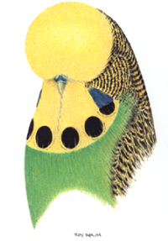
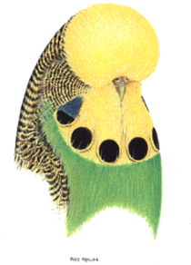

General Secretary
Leigh Downey
PO Box 140
OAKLEIGH SOUTH 3167.
AUSTRALIA
Ph: +61 95793429
Mob: +61 0417569197
Email: anbcsecretary@outlook.com

COUNCIL CHATTER.
December 15, 2017.

Good morning and welcome to the final comments for another year.
I have a positive position on the advancement of the A.N.B.C Containerization for all equipment for the staging of the National Competition. All Zones have contributed to the funding for this to proceed as per the working spread sheet. Dave Ganzer has taken on this task so firstly we all thank you Dave for your input and commitment. We have purchased the container, holding cages, hospital cages, and we will also have 251 new and refurbished show cages in the container. As well as lighting and staging. It is all at Dave’s place and he will be in discussions with B.S.N.S.W. to make it all happen in Penrith N.S.W. next May.

ELECTRONIC MEDIA.
The first meeting conducted in October was on our own computer program and was widely received and a great success. Most personal from all zones seem to be adapting to this format of advancing information, and making decisions in a timely manner.

PHOTOS & STANDARD.
Rod Turnbull has released a few more standard photos of some varieties. As with the Standard, Mr. Peter Glassenbury (Colour & Standards) is looking at a separate section fully of variety photographs only to be added to the website when completed. The Standard is now on the web and is the updated current copy.

As with the pictorials included in the Standard we have decided that the paintings of the National Standard Pictorial of which there are three. One full length bird, one dual headed, and one pencil black and white drawing. Should be auctioned at the next National Event in PENRITH N.S.W. 2018.
These were done by the famous bird artist Mr. Roy Aplin from the United Kingdom.
They were painted in 2002 and while they are an asset for the A.N.B.C. they are no longer required as we have scanned copies should they ever be required. It was decided that a bird fancier, art collector should be able to have the enjoyment to view these paintings at their leisure.

INSURANCE.
We are still awaiting the broker’s quotation on an A.N.B.C. total Insurance policy to see if it is viable for us to go our own way totally nationally. Also one zone was not forthcoming with general figures asked for to complete this task. We do these things for the benefit of all hopefully, so hurdles only make tasks like this just a little bit more aggravativly harder.

CONSTITUTION DRAFT DOCUMENT.
South Australia has submitted a revised constitution document for everyone to read and digest. It is put up as a motion in May 2017 to be discussed for the next meeting. It was accepted and ratified by a majority in the electronic meeting in October 2017 with a couple of minimal changes being allowed to be added at the request of S.Q.B.B.A. which hopefully will be accepted and signed off in May 2018.

MOTIONS FOR COLOUR & STANDARDS.
Again I believe all motions relating to this sub- committee are now overdue so if any zones have anything they wish to bring to their attention please do so post haste. Forward to Mr. Peter Glassenbury. The survey conducted on FLECKING was returned by all Judge with some very good input. Thank you.

WEB SITE.
Karlene from Nth. Queensland has updated the web site and ongoing maintenance of it is still happening. We have had a couple of hick-ups but hopefully positive improvements are still in the pipeline. As you all know Steve Campbell is retired and I thank him for all his input over the previous years.

BUDGERIGAR SOCIETY OF NEW SOUTH WALES.
Hosting of the 2018 National Championships by the Budgerigar Society of New South Wales in Penrith.
They have now released the registration paper work accommodation etc. Look out for it and start planning your trip in May 2018.

If I have forgotten anything please accept my apology as it has been a full on eventful year. Plenty of hurdles to overcome again.
Rings for 2018 should now be in the mail for your availability to ring birds by the first week of January 2018.
Until then MERRY CHRISTMAS & HAPPY NEW YEAR TO ALL.

Leigh A Downey.

ANBC Secretary

ABN 46- 620 – 174 - 965

