AUSTRALIAN
NATIONAL
BUDGERIGAR
COUNCIL Inc.
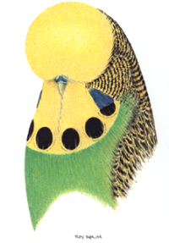
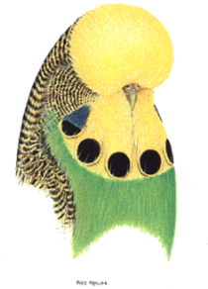

General Secretary
Leigh Downey
PO Box 140
OAKLEIGH SOUTH 3167.
AUSTRALIA
Ph: +61 95793429
Mob: +61 0417569197
Email: anbcsecretary@outlook.com

COUNCIL CHATTER.
JULY 2018

Two prominent issues from the 2018 and 2016 ANBC National Judges meetings will be implemented during this coming year.

These two issues will affect all judges’ and breeders alike moving forward and are to be clearly explained by State Controlling Bodies to all parties within your state.
Not doing this will be at your peril.

The issues relate to Penalty and Disqualifications and will come into effect from
1st January 2019.

Issue 1 – FLECKING

Two pictorial depictions of birds with what is deemed as Heavy Flecking will form part of the updated Standard and importantly birds displaying these levels of Flecking are to be DISQUALIFIED by Judges.

A further pictorial will be inserted with birds that are deemed to have Light Flecking and while these birds will be accepted on the show bench they will be subject to the current penalty processes of the heavier the Flecking the heavier the Penalty.

Any bird that requires a Judge to deliberate as to the birds position within the scales applied are to be treated as having Heavy Flecking and again be
DISQUALIFIED by the Judge.

These Guidelines are to be applied at shows at all levels that are subject to the guidance and principles of the ANBC Standard.

Issue 2 – AUSTRALIAN GOLDEN FACE

In 2016 ANBC Judges also decided as to actions in judging this particular variety.

To revisit this for all a determination was made that within 3 years the body colour is to be Blue (includes Grey Factor) with a timeframe of full implementation for the 2019 National Show.

The Standard was changed to reflect the interim position of colour whereby no points were allocated for these poorly coloured birds.

The next stage of this decision comes into play at the National Show in 2019.

Effectively this now means that birds that are deemed to be green and grey green in body colour and do not depict a colour of Blue or Grey are not be accepted on the show bench.

The words of Single and Double factor are also to be removed from the Standard as part of this determination.

PLEASE ENSURE ALL PARTIES ARE AWARE OF THESE IMPORTANT CHANGES

Leigh A Downey.

ANBC Secretary

ABN 46- 620 – 174 - 965

